“Dear America”- English 12-Ms. Mathews-Activism & Research Writing Sample
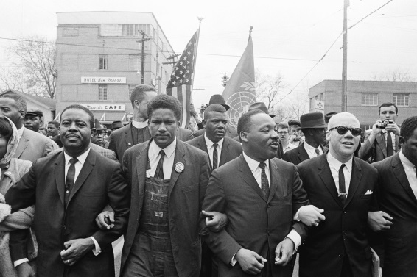
Mode: Letter Writing assignment with facts from the movie Selma and data from http://www.cnn.com/election/results and http://www.cnn.com/election/results/exit-polls .
Audience: American Society in the current year. You may narrow the focus of your audience if you choose.
Purpose: To explain a problem of the lack of voting in your country and describe possible solutions.
Situation: After starting your paper with the greeting of Dear America, write a letter that is no longer than a typed page or two handwritten pages (in ink) supported with facts to support the point of view (use your storyboard for assistance). You must have two events from the movie. You must use at least two facts from this sites provided also. While working, make reference to facts on http://www.cnn.com/election/results and http://www.cnn.com/election/results/exit-polls. Make sure to close with Sincerely or Regards and to use Times New Roman, font size 12 if you type. If hand written, write clearly in the assignment section of your notebook. Lastly, sign the letter with your full name and print your name above the signature. This is due Thursday. It must be turned in ON TIME (beginning of the hour for full credit-NO late papers will be accepted. If you are absent, email to jmathews@carmanainsworth.org at the start of your hour. NO exceptions!).

